Makro aflevering 1
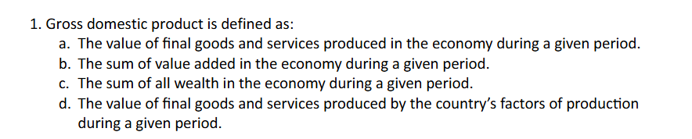
A,b are true
C is just straight wrong
D is the definition of gnp not gdp which one could get confused
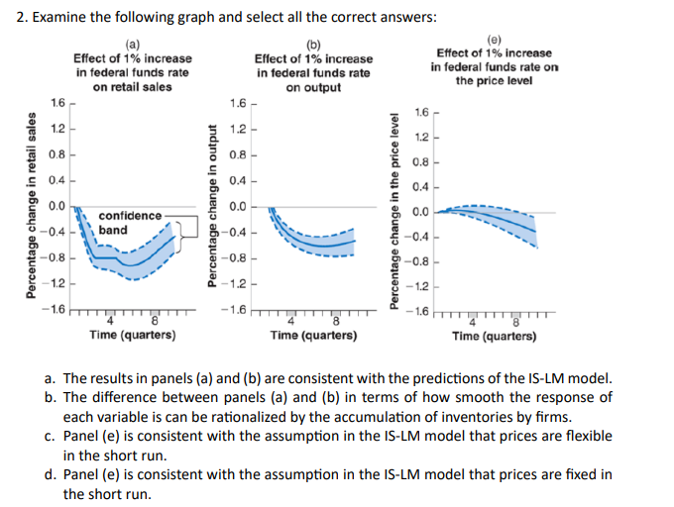
$$Y=C\left(Y-T\right)+I\left(Y,i\right)+G$$
$$i=\overline{i}$$
- True: a rising of rates leads to degreased investment which means decreased demand and thus decreased output(which we expect to be a little delayed
Islm says when rates increases demand and supply decreases(all else equal)
- True: a firm will need to react to a change in demand
- False in the short run we assume prices to be constant in the islm model which they seem to be
- True
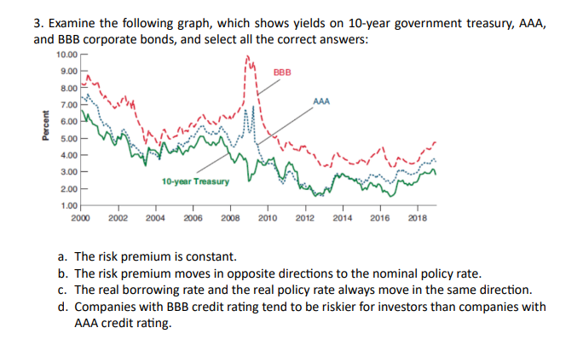
a) false see 2009(risk premia on AAA larger than 0) vs 2004(risk premium is zore if not negative on AAA)
b) false see 2009
c) false
d) true by Construction since the credit rating is exactly the risk and a rating of BBB is worse than a rating of AAA
also in the graph we see that the risk premium IE the gap between treasuries and BBB is lager than the than the risk premium on AAA
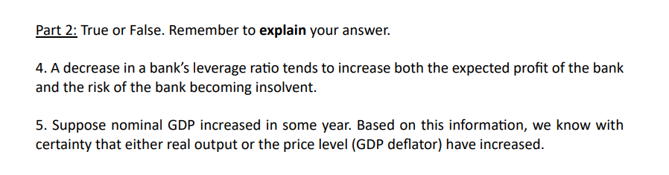
4) false
Banks needing to have a higher reserve rate means that they are able to loan out less money meaning a lover profit, this also means that the risk of insolvency is lover since there needs to be more people withdrawing at the same time for the bank to become unable to pay out
5) true

Given the formula for the relationship between real and nominal GDP :
$$Y_{t}\$=Y_{t}·P_{t}$$
We must have the simple implication
$$Y_{t+1}\$>Y_{t}\$⇒Y_{t+1}>Y_{t} or P_{t+1}>P_{t}$$
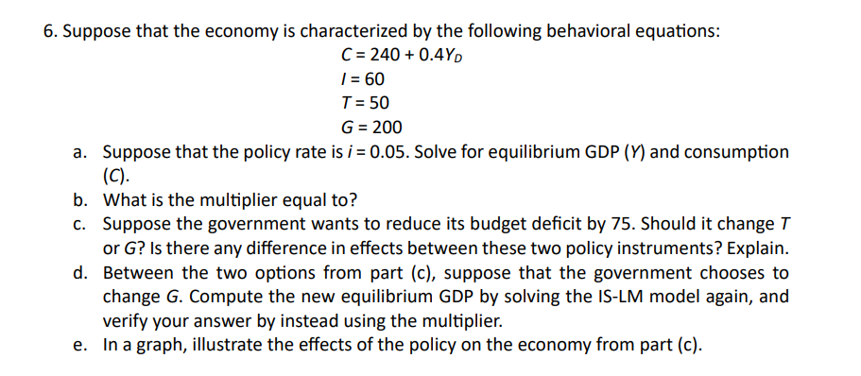
- In eq
$$Y=Z=C\left(Y-T\right)+\overline{I}+G$$
$$Y=240+0.4\left(Y-50\right)+60+200$$
$$Y·\left(1-0.4\right)=240-20+60+200$$
$$Y=\frac{1}{0.6}·\left(240-20+60+200\right)=800$$
$$C=240+0.4·\left(800-50\right)=540$$
- Multiplier
$$=\frac{1}{0.6}≈1,666667$$
- Decrease gov spending by 75 how can we do it and how does it affect the economy
We can either increase T or decrease G to decrease $G-T>0$
To maximise output we can simply look at the equation from before
$$Y=\frac{1}{0.6}·\left(240-0.4·T+60+G\right)$$
If we want to maximise output we would rather increase taxes than decrease government spending this also makes intuitive sense since
$$Y=C\left(Y-T\right)+\overline{I}+G$$
A decrease in taxes have an indirect effect on output while a decrese in government spending would have a direct effect on output thus if the goal is to max output we just increase taxes by 75
- New eq with $G=125$
$$Y·\left(1-0.4\right)=240-20+60+125$$
$$Y=\frac{1}{0.6}*\left(240-20+60+125\right)=675$$
Verify with muliplier

$$800-75·\frac{1}{0.6}=675$$
Which is the expected answer
- Illustrate on graph:
We see that when government spending decreases output decreases which can be decomposed into these steps where first demand changes and after output adjusts
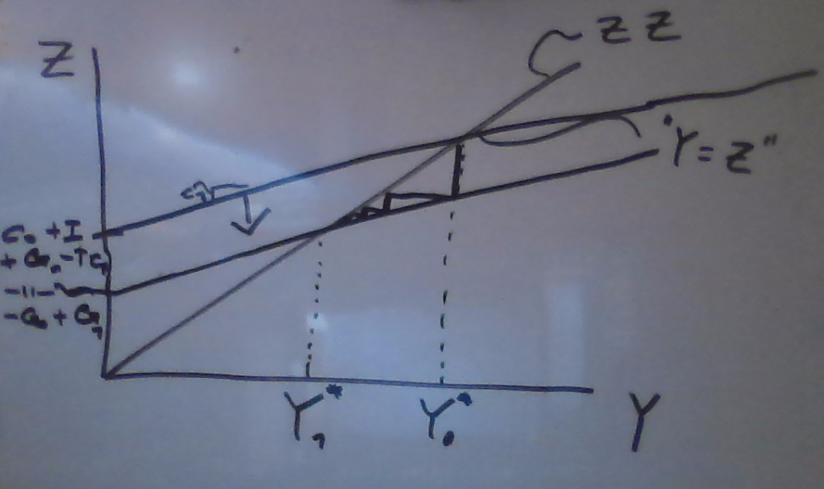
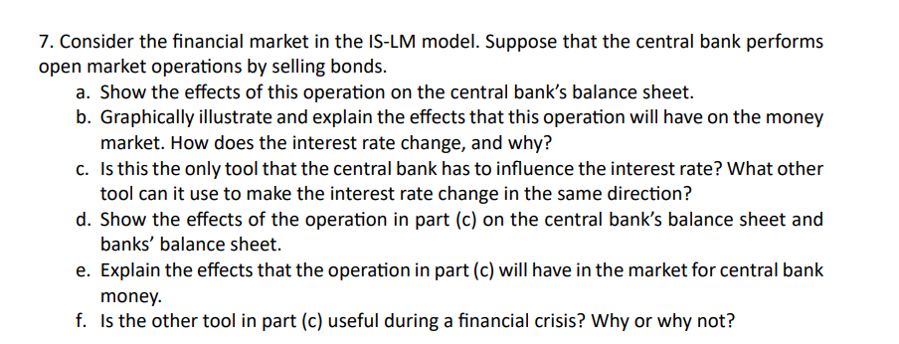
- Balance sheet
Central bank | assets | Liabilities
Start: | Bonds | Central bank money=  Reserves + Currency
Central bank sells bonds | Bonds$↓$ | Reserves + Currency$↓$
- Explain in graph and words
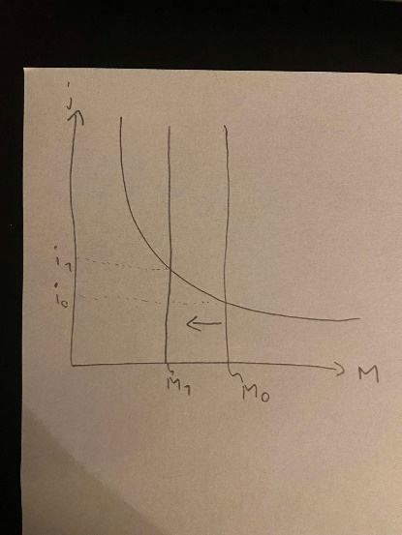
When the central bank sells bonds the supply of bonds increase lowering the price of bonds which means a rate on the bond increases
- tools
the other way the central bank can influence rates is by increasing the reserve rate $θ$ in the flowing equation for the demand for central bank money
$$H^{d}=θ·M^{d}=θ·Y \$·L(i)$$
Having constant supply of central bank money means a decrease in money demand and thus increase in intrestrates
- Balance sheet part 2
When we increase reserve requirements we have:
Central bank | Assets | Liabilities
 | Bonds | Central bank money = Reserves + currency

And the bank:
bank | Assets | Liabilities
 | Bonds  Loans$↓$  Reserves | Checkable deposits$↓$
- Explain what happens
Same as before the amount of money in circulation falls thus the interest rate increases see drawing from b
Also if we know that supply of central bank money is constant so in eq we must have
$$H^{s}=H^{d}=M^{d}·θ⇔M^{d}=\frac{H^{s}}{θ}$$
Especially when central bank money supply doesn’t change but theta falls we see
$$θ^{'}>θ⇒{M^{d}}^{'}=\frac{H^{s}}{θ'}<\frac{H^{s}}{θ}=M^{d}$$
And we know that if money demand falls interest rates must rise since output and prices are assumed constant
- Is this useful in a financial crisis?
Increasing reserverates could increase stability and faith in banks, in a financial crisis we would usually want a lowering in interest rates to increase output which would require a lowering of the reserverate which would increase risk of insulvancy which wouldn’t make sense to do when the economy is already threatened so I suppose it depends on the crisis but I at least don’t think its clear cut

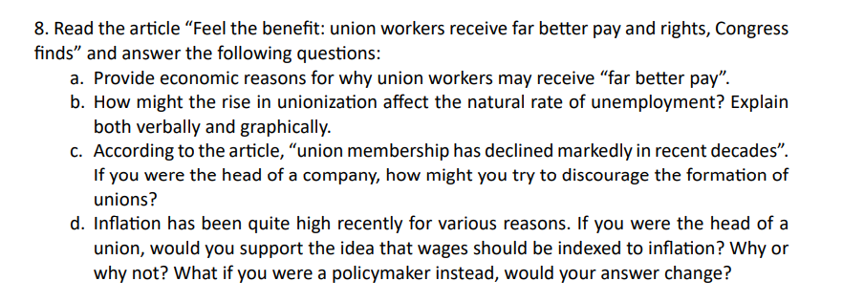

- Reasons why union workers may receive better pay
Writing up the wage setting equation
$$\frac{W}{P}=F(u,z)$$
A unionizing must mean an increase in the catchall variable due to the ability to bargain as a union increasing wages a strong union one could argue would be able to force the firms to take a lesser markub giving us the price setting equation
$$W(1+m)=P$$
Forcing m down giving workers a higher wage

- How does it affect the natural rate of unemployment
When wages go up firms will hire less and less at those wages increasing unemployment decreasing bargaining power until we hit eq again now with higher unemployment at same real wage

One could argue that the union gains power to force down the markup of firms
Giving us a new eq with higher unemployment and higher wages at the arrow
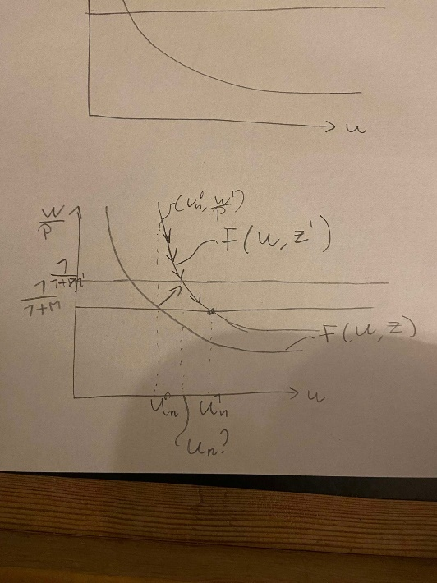
- How do we prevent unionization
Dont give them reason to want to unionise, give them good wages, good benefits basically give them everything a union would maybe just a little cheaper
- What would a union leader choose indexed wages why/why not? Would a policy maker?
When indexed wages are increased we get accelerated inflation and deflation seen In the equation
$$π_{t}-π^{e}=-\frac{a}{1-λ}·(u_{t}-u_{n})$$
Meaning if I was a policy maker which goal it is to make inflations stable I would wish for non indexed wages meaning $λ=0$ because if not then a what otherwise would have been a 1% increase in inflation becomes a $\frac{1}{1-λ}\%$ increase in inflation thus making it more probable that inflation/deflation will spiral
If I were a union leader I would want to maximize the real wage of my workers over time where wage indexation makes sense as this lets the workers not loose real wage to inflation.
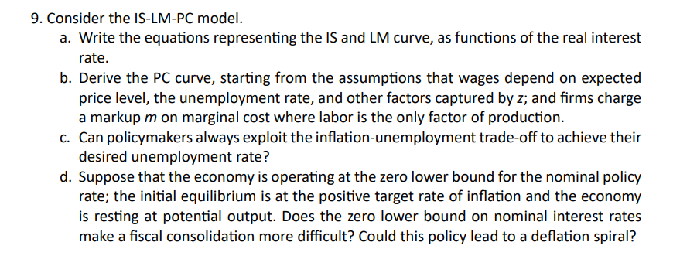

$$Y=C\left(Y-T\right)+I\left(Y,r+x\right)+G$$
$$r=\overline{r}$$
- We are told that the following is a good representation of F
$$F\left(u,z\right)=1-α·u+z$$
We have the price and wagesetting equations giving us
$$P=\left(1+m\right)·W$$
$$W=P^{e}·F\left(u,z\right)=P^{e}·\left(1-α·u+z\right)$$
$$⇒P=\left(1+m\right)·P^{e}·\left(1-α·u+z\right)$$
We divide by $P_{t-1}$ and subtracting 0
$$1+\frac{P_{t}-P_{t-1}}{P_{t-1}}=(1+\frac{P^{e}-P_{t-1}}{P_{t-1}})*\left(1+m\right)·\left(1-α·u+z\right)$$
Now take logs
$$\log\left(1+\frac{P_{t}-P_{t-1}}{P_{t-1}}\right)=\log{(1+\frac{P_{t}^{e}-P_{t-1}}{P_{t-1}})}+\log{(1+m)}+\log\left(1-α·u+z\right)$$
Then we approximate since $\log\left(1+x\right)≈x$ for small x
$$\frac{P_{t}-P_{t-1}}{P_{t-1}}=\frac{P_{t}^{e}-P_{t-1}}{P_{t-1}}+m-α·u+z$$
$$π=π^{e}+m-α·u+z$$
Defining natural unemployment as $u_{n}$ when $π=π^{e}$
$$0=m-αu_{n}+z⇔u_{n}=\frac{m+z}{α}$$
We put into the earlier equation and get
$$π-π^{e}=m-α·u+z=-α·(u-u_{n})$$

- .
Yes by increasing or decreasing output we can increase or decrease inflation thus py the philipscurve controlling unemployment this only works in the short run tho
in the long run unemployment will go to the natural rate of unemployment and a try to adjust this way will only change inflation
- .
Yes it makes it difficult wince were at the ZLB if government tries to make fiscal consolidations it will reduce demand and therefore output while were unable to decrease rates due to the ZLB thus meaning we have no way of increasing inflation thus creating risk of a deflationary spiral

